Data Pre-processing Interview questions

1. What is numpy array? Where we can use it?

- A numPy array is a multidimensional data structure that represents a grid of values, all of the same type. It is the fundamental data structure used in the NumPy library, which is a powerfull tool for numerical computing in python.

NumPy arrays are used in variety of applications, including:

1. Mathematical and logical operations. NumPy arrays provide efficient and fast mathematical operations on large datasets of data. They can be used for task such as matrix multiplication, element-wise operations and various mathematical functions.

2. Data analysis and manipulation: NumPy arrays are commonly used in data analysis tasks, such as filtering, sorting and aggregating data. They can be easily combined with other libraries like pandas for more advanced data manipulation.

3. Scientific computing and simulations: NumPy arrays are widely used in scientific computing for tasks such as filtering , and aggregating data. They can be easily combined with other libraries like pandas for more advanced data manipulation.

4. Machine learning and data mining: NumPy arrays are the preffered data structure for many machine learning algorithms. They can be easily fed into machine learning models and can efficiently handle large datasets.

Overall, NumPy arrays are a versatile and essential tool for numerical computing and data analysis in Python.

2. What is purpose of pandas package? How can be a data analyst benifitted from using the pandas package? Give some examples.

The purpose of pandas package is to provide data manipulation and analysis tool for python. It is built on top of NumPy and provide easy to use data structures and data analysis tools:

Data analysis can benefit from using the pandas package in several ways :

1. Data cleaning : pandas provide functional and methods for cleaning and preprocessing data. Analyst can easily handle missing data, remove duplicates and perform data transformations.

Example: A data analyst can use pandas to remove rows with the missing values from the dataset, impute missing values using mean or median, or drop duplicates rows.

2. Data Exploration: pandas allows analyst to explore and understand the data by providing functions for summarizing and visualizing data. It enables quick data profiling and descriptive statistics.

3. Data manipulation: pandas provides powerful tools for manipulating and transforming data. Analyst can filter, sort, group and aggregate the data easily.

4. Data Integration: pandas allows analysts to combine and merge datasets easily, enabling them to work with the data from multiple sources. – an analyst can use pandas to merge two datasets based on a common key, combine dataset vertically or horizontally, or concatenate multiple datasets into one.

5. Time series anlaysis: pandas provide specialized data structures and functions for working with time series data. Analyst can easily handle time-based data , resample and perform the time-based calculations.-A data analyst can use pandas to convert a column of timestamps into a time series object, resample the data at a different frequency (e.g. daily to monthly) or calculate rolling avgs. Or cumulative sums over time.

Overall pandas simplifies and accelerates the data anlalysis process for analysts by providing a wide range of data manipulation and analysis tools.

3. What is the RegEx in Python? Give some practical examples of the same.

Regular expressions, also known as regex, are sequences of characters that defines a search pattern. They are used to match and manipulate strings based on patterns. Python provides a built-in module called “re” that allows us to work with the regular expressions.

Here are some of the examples:

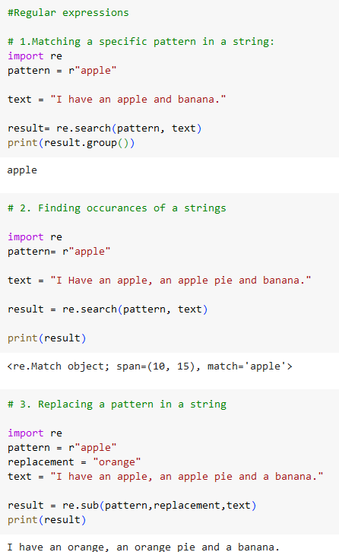 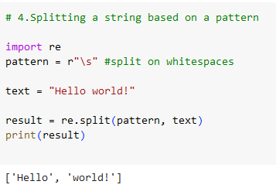

4. What is the Exploratory Data analysis. EDA? Explain in detail.

Exploratory data analysis EDA is a statistical approach used to analyze and summarize the main characteristics of a dataset. It involves visually and numerically examining the data to gain insights, detect patterns, identify outliers and understanding the underlying structure or relationships within the dataset. EDA is typically performed before applying more formal statistical techniques or building predictive models.

The main objectives of EDA are:

1. Data cleaning: EDA helps in identifying and handling the missing values, outliers and inconsistencies in the dataset. It involves tecniques like imputation, removing duplicates and correcting errors to ensure the data is of high quality.

2. Data visualization: EDA utilized various graphical techniques to visually explores the dataset. This includes histograms, scatter plots, box plots and bar charts and heatmaps visualizations helps understand the distribution of variables, identify the trends or patterns, and detects anomalies or outliers.

3. Data summary : EDA provides summary statistics and descriptive measures to summarize the dataset. This includes the measure like mean ,median , mode , std dev., range and shape of the data distribution.

4. Data relationship : EDA helps understand the relationship between the variables in the dataset. This involves the calculation of the correlation coefficients , performing cross-tabulations and creating the scatter plots or correlation metrics. By exploring these relationships, one can identify potential predictors or explanatory variables for further anlaysis.

5. Hypothesis generation: EDA aids in generating the hypothesis or research the questions based on initial observations. By exploring the data, researchers can identify interesting patterns or trends that can lead to further investigation or hypothesis testing.

6. Data transformation: EDA involves transforming variables or creating new variables to better represent the underlying patterns in the data. This can be include logarithmic transformations, standardizations, or creating interaction items. Data transformation can helps improve models accuracy or make the data more suitable for analysis.

Overall, EDA is a crucial stage in the data analysis process as it helps understand the dataset, identify the potential issues, and formulate further research questions. It allows researchers to gain the insights and make the informed decisions about the data, leading to more accurate and meaningful analysis.

5. How do you differentiate the JOINS in pandas. Explain with the help of examples.